**Practical 4**

**Demonstrate an IoT based game which can be played between two player who are physically at a considerable distance**

**Steps to Perform:**

**Step 1:** 1) Take Fan

2) Take Window

3) Take Smart Phone

4) Take Thermostat

5) Take DLC (Home gateway)

**Step 2:** 1) Now we will connect Thermostat to DLC (Home gateway)

Copper Straight cable connect Thermostat (Fastethernet0) to DLCBoard (Ethernet1)

2) Then go to DLC (Home Gateway) config IP

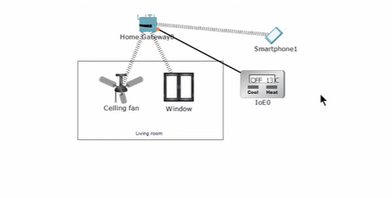

**Step 3:** 1) Now we will click Thermostat then go to config change display name and select Home gateway then click on FastEthernet 0 then select IP configuration DHCP

2) Then go to Smart Phone then click on Desktop then click on conditions and click on add

Name – Turn the celling fan

